**NAME: SHAIK.ANISA AZMI**

**TRAINER NAME: HARSHEE PITRODA**

**COURSE NAME: PYTHON & MACHINE LEARNING BASICS**

**DATE:06/06/2022**

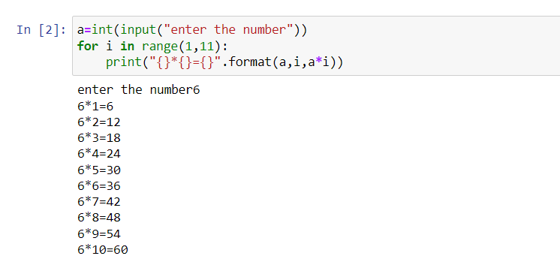**2.**https://www.hackerrank.com/challenges/python-loops/problem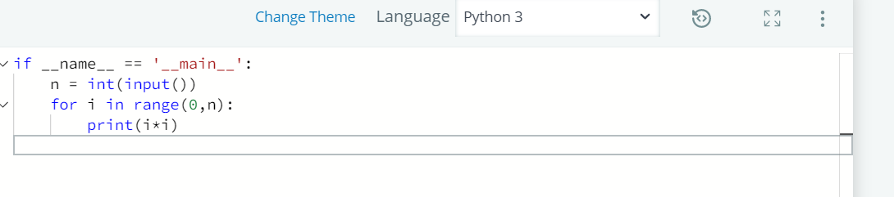

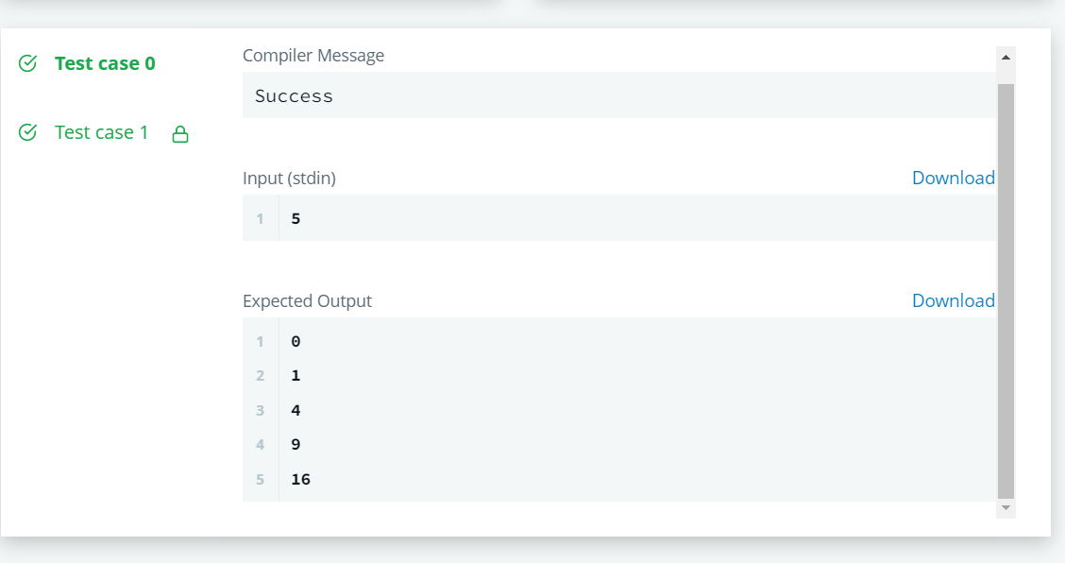**3.**https://www.hackerrank.com/challenges/py-if-else/problem?isFullScreen=true

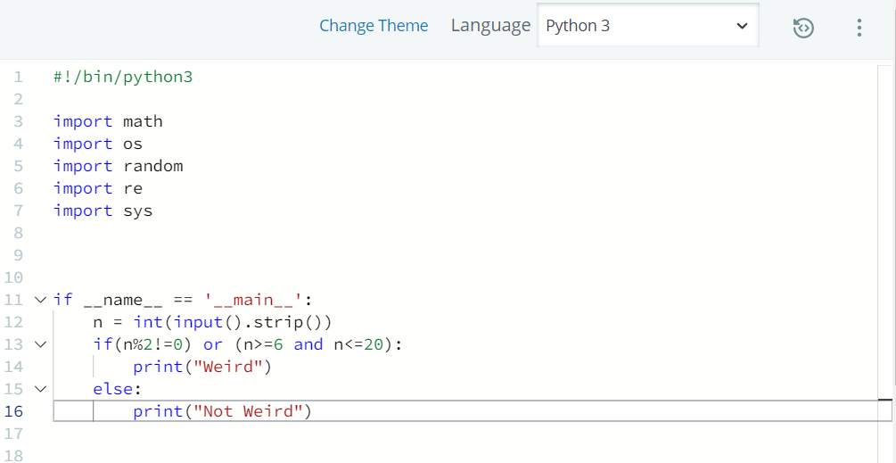

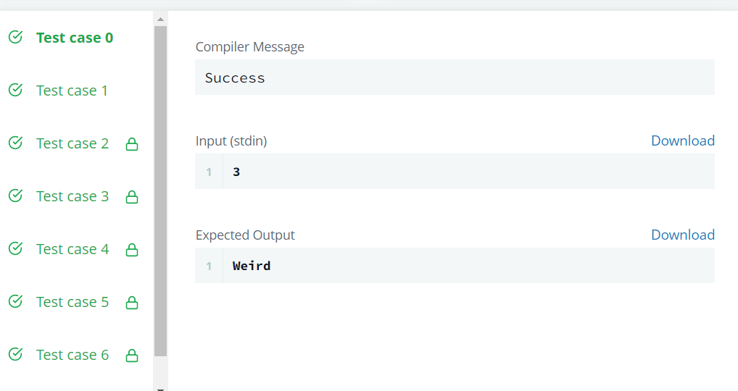**4.**https://www.hackerrank.com/challenges/whats-your-name/problem?isFullScreen=true

